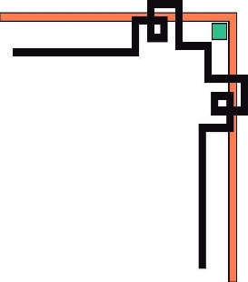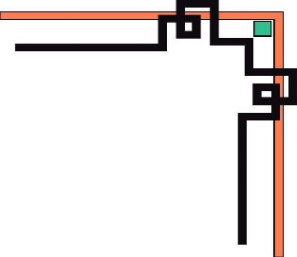

**DANANG SOFTWARE CORPORATION**

**SOFTECH-APTECH**



EProject :

SALON HAIR

Guiding faculty : TRINH THI THUY TIEN

Members :

* NGUYEN ANH TAN
* TUONG THI LINH

Group: 01

Batch: 130

**Da Nang, 15th January 2017**

I. ACKNOWLEDGEMENTS 4

II. INTRODUCTION 4

1. you can consult and booking at our website. 4

2. you can purchase products care hair at our website. 4

III. TARGETS AND OBJECTS OF THE RESEARCH 4

1. Research Targets 4

2. Research Objects 4

IV. PROBLEM DEFINITION 4

V. REQUIREMENT ATTRIBUTES 5

1. Main Requirements 5

2. Use case Diagram 5

VI. PROJECT PLANNING 6

VII. LAYOUT WEBSITE 6

1. Home page 6

2. Home page 2 6

3. Home page 3 8

VIII. GUI PROTOTYPE 9

1. Home Page 9

2. T&L SALON 9

3. T&L SHOP 16

IX. REFERENCES 20

X. GUI OF WEBSITE 20

XI. CHECKLISTS 20

1. Check list of validation 20

2. Submission Checklist 20

Danang, Vietnam, 09/02/2017

**TEACHER’S EVALUATION**

………………………………………………………………………………………………………………………………………………………………………………………………………………………………………………………………………………………………………………………………………………………………………………………………………………………………………………………………………………………………………………………………………………………………………………………………………………………………………………………………………………………………………………………………………………………………………………………………………………………………………………………………………………………………………………………………………………………………………………………………………………………………………………………………………………………………

………………………………………………………………………………………………………………………………………………………………………………………………………………………………………………………………………………………………………………………………………………………………………………………………………………………………………………………………………………………………………………………………………………………………………………………………………………………………………………………………………………………………………………………………………………………………………………………………………………………………………………………………………………………………………………………………………………………………………………………………………………………………………………………………………………………………

………………………………………………………………………………………………………………………………………………………………………………………………………………………………………………………………………………………………………………………………………………………………………………………………………………………………………………………………………………………………………………………………………………………………………………………………………………………………………………………………………………………………………………………………………………………………………………………………………………………………………………………………………………………………………………………………………………………………………………………………………………………………………………………………………………………………

# I. ACKNOWLEDGEMENTS

During the process of the study, my groups received support and help from the teacher instructors.

At first, our group would like to thank deeply to the attention of leaders Softech – Aptech, the teacher teach for us.

Expecially, I thank deeply to Trinh Thi Thuy Tien, who help and facilitate for us.

In process of implementing, due to limitations of time and experience so we don’t avoid being errors. We hope to the teacher’s suggestions which make this report perfectly.

# II. INTRODUCTION

T&L SALON is the website that allows you to mange and share your hairstyle beautiful – there are 2 main purpose:

1. **you can consult and booking at our website.**

Here you can learn a lot from the beautiful hairstyle and prevailing worldwide. to meet the needs of our society constantly updating hot hair samples sent to you.

Here is also possible to place. Our facility has supported professional styling for most of the stars in the world and they are also very pleased when they walked out of the salon.

We open yourself a nice salon and a fully equipped 100%. You can also order directly to us via this website.

1. **you can purchase products care hair at our website.**

Welcome to the T & L SALON.

In this place we have to sell a full range of hair care products for professionals worldwide star and other products.

In addition, we also give you guidance on how to use it and how to use it effectively. If you do not have time to look at the T & L SALON, then you can order at this website, simple methods inexpensive cost too much.

# III. TARGETS AND OBJECTS OF THE RESEARCH

1. **Research Targets**

The objective of this project we want to introduce a hairdressing salon and selling hair care products

We can take to sit for hours outside shops and wait until your strategy. Instead we can put a chair right in your own home to save time waiting

You can also consider and purchase your favorite products in your home by going to our website

1. **Research Objects**

Fashion and business

# IV. PROBLEM DEFINITION

1. **A Home page**

As the site's main page , it will be for users to view important information . And links to the other pages .

1. **About Us**

Information will be written clearly in our website. You can look at it

1. **Menu**

The menu is full of information and links to other pages together. You can through it to get to other pages faster can

1. **Prices and Scheduling**

Hair samples provide nice price and opening times in T&L SALON.

1. **Products and Item details page**

All hair care products sold in T&L SALON

1. **Hairstyle**

Place to choose for your hair

1. **Guide**

Place to share the video hairdressing

1. **Tie your hair**

Where you can decorate your hair

1. **Contact page**

Contact page is the support. This section helps the user to find the answer for their questions as well as how to contacting us. Contact page is a pretty important site in website. Because it let everyone contact us with question or for assistance as well as given us feedback by entering their personal information will be send to us. This contact page to collect the opinions of the users, help us to improve our website for even better.

1. **Other**

Daily tips for beautiful hair

1. **Login**
2. **Join**
3. **Service website**
4. **Connect with Facebook, YouTube, Gmail**
5. **Shopping cart**
6. **Footer page**

# V. REQUIREMENT ATTRIBUTES

1. **Main Requirements**

The Main Requirements include HTML5, CSS3, Bootstrap, Jquery

1. 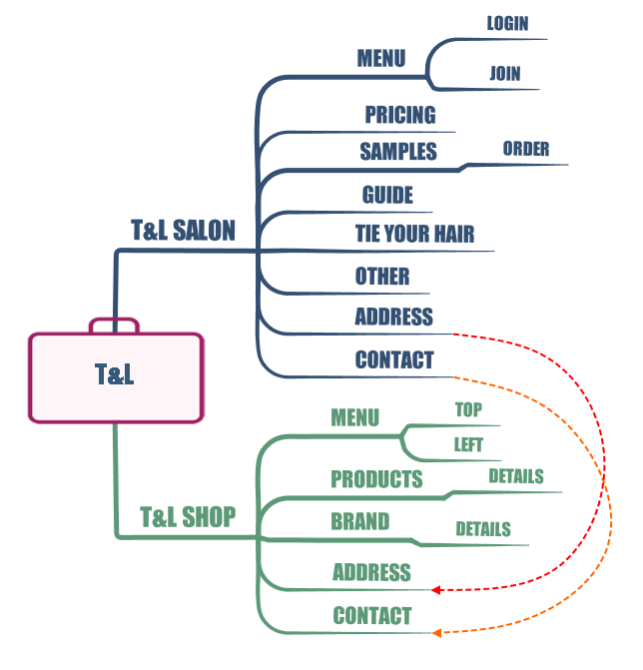**Use case Diagram**

# VI. PROJECT PLANNING

# VII. LAYOUT WEBSITE

1. **Home page**

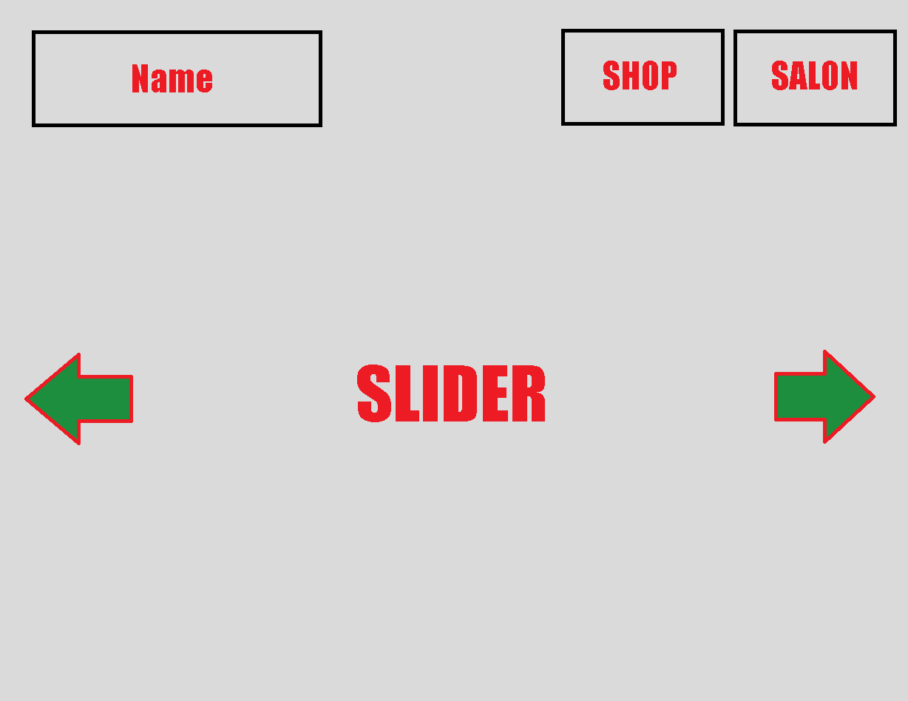

1. **Home page 2**

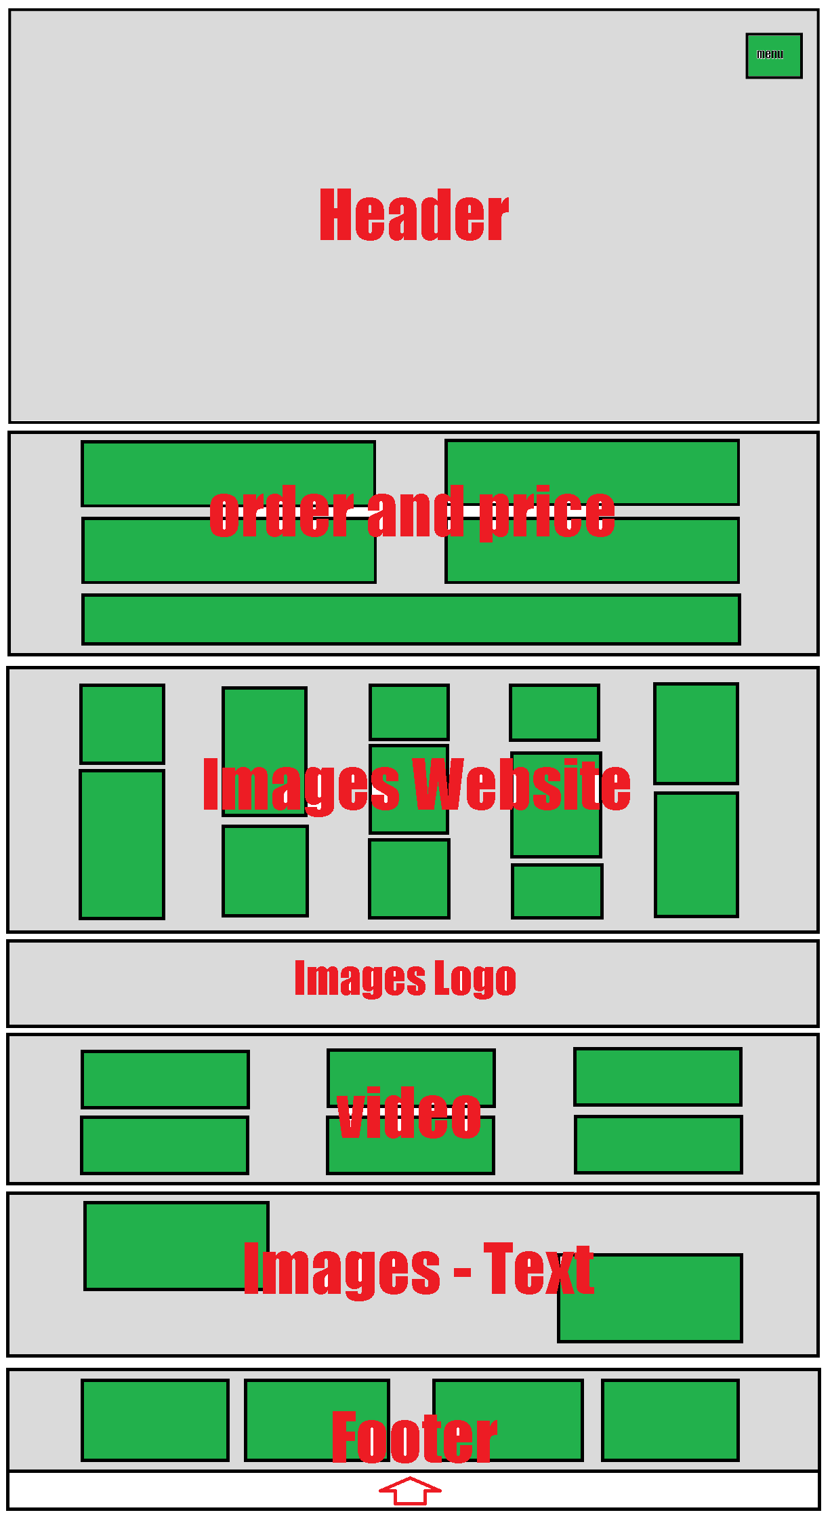

1. **Home page 3**

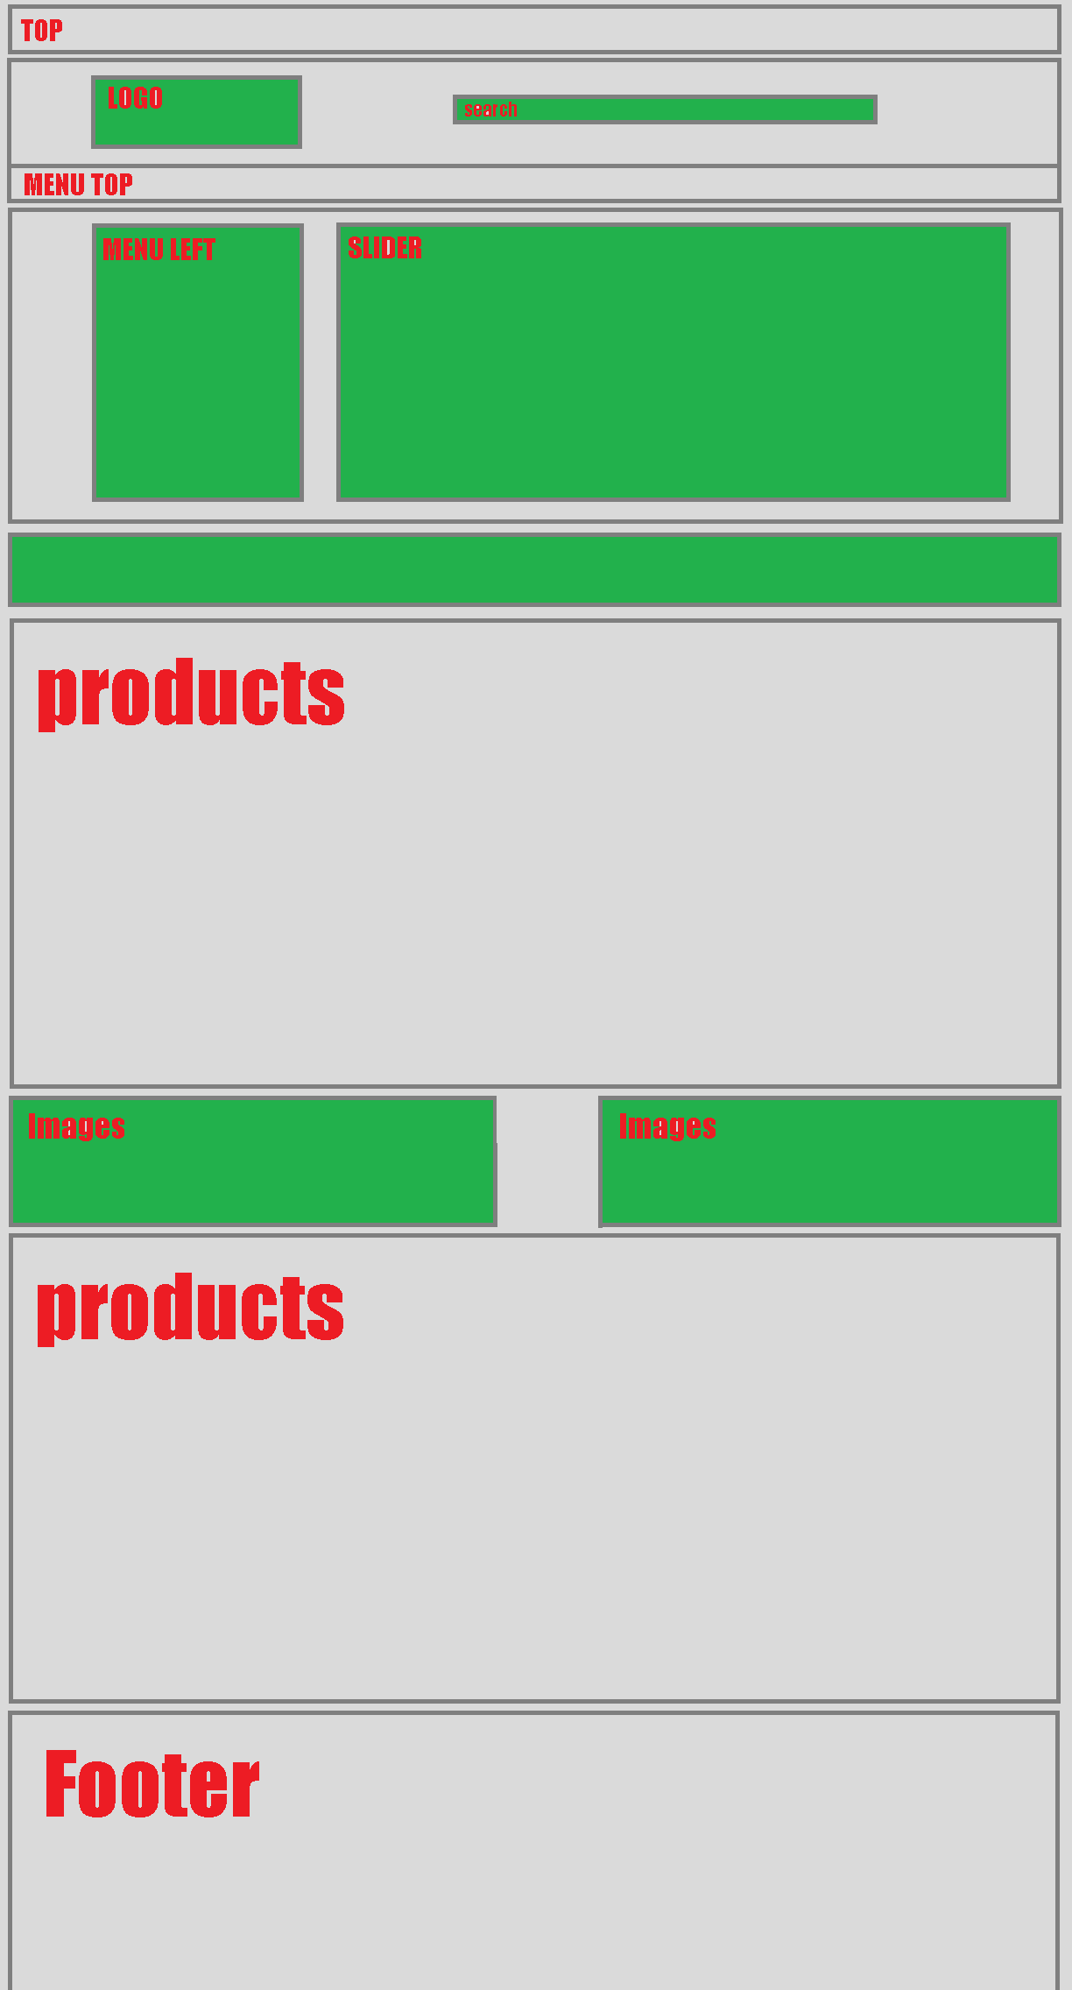

**VIII. GUI PROTOTYPE**

1. **Home Page**

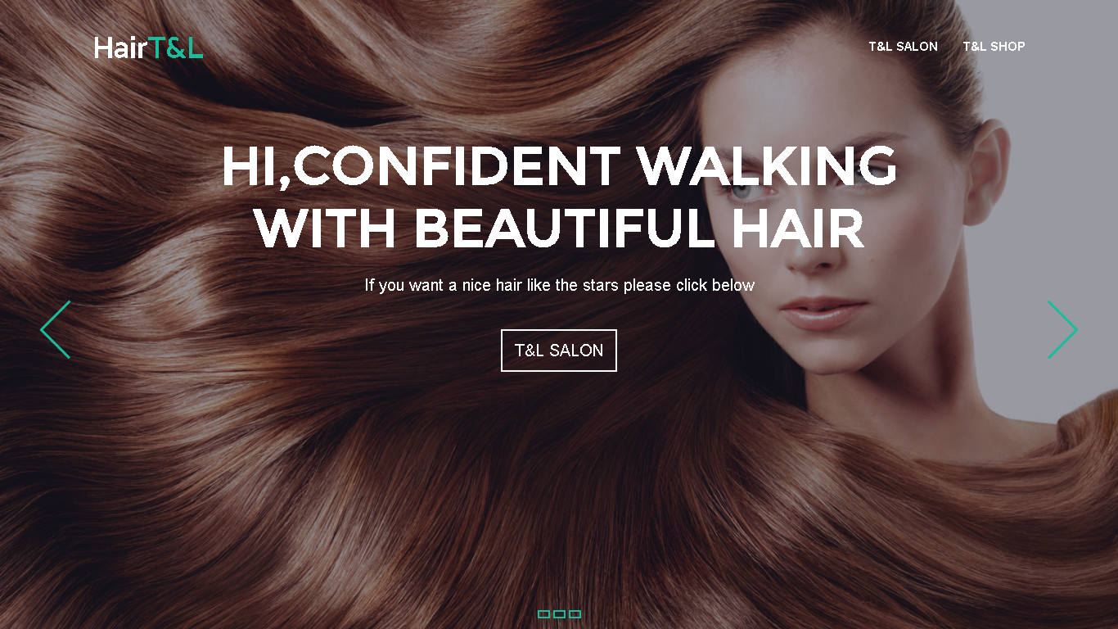

1. **T&L SALON**

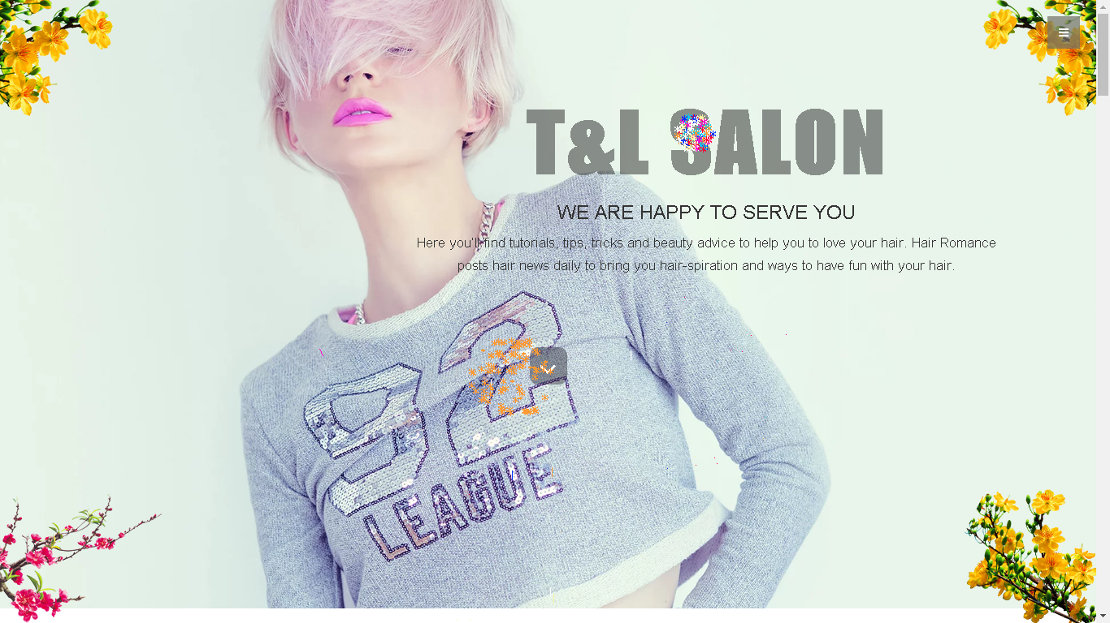

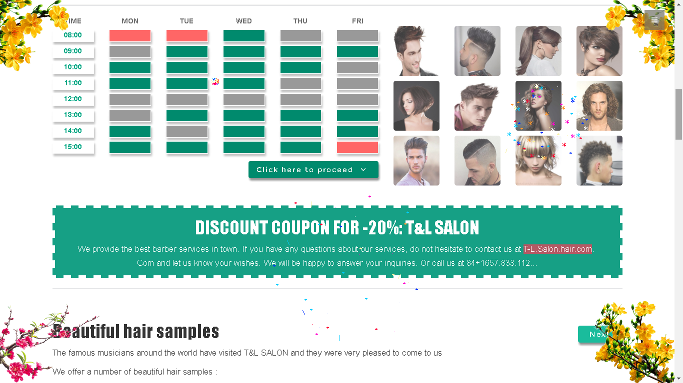

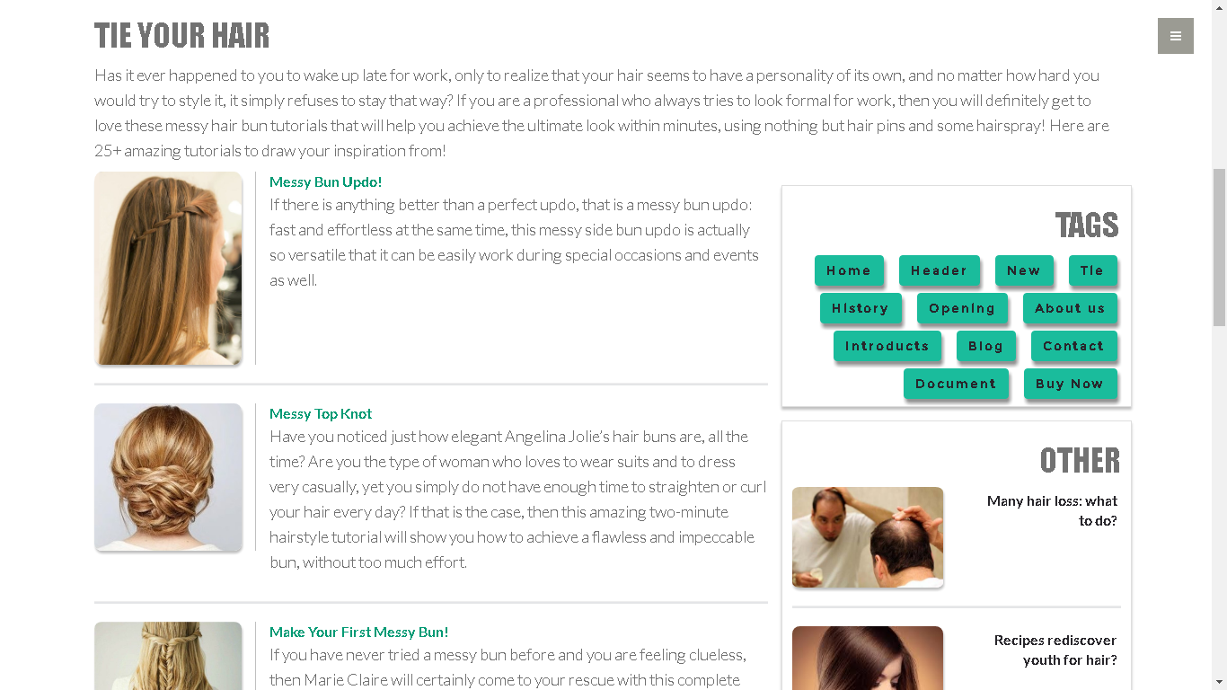

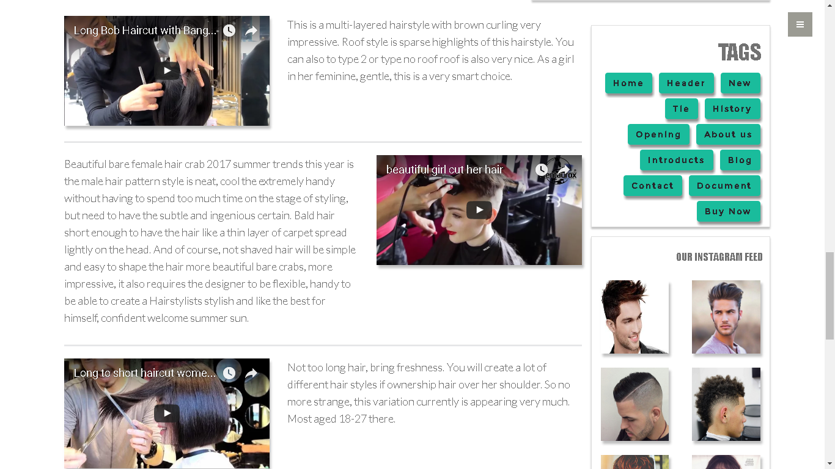

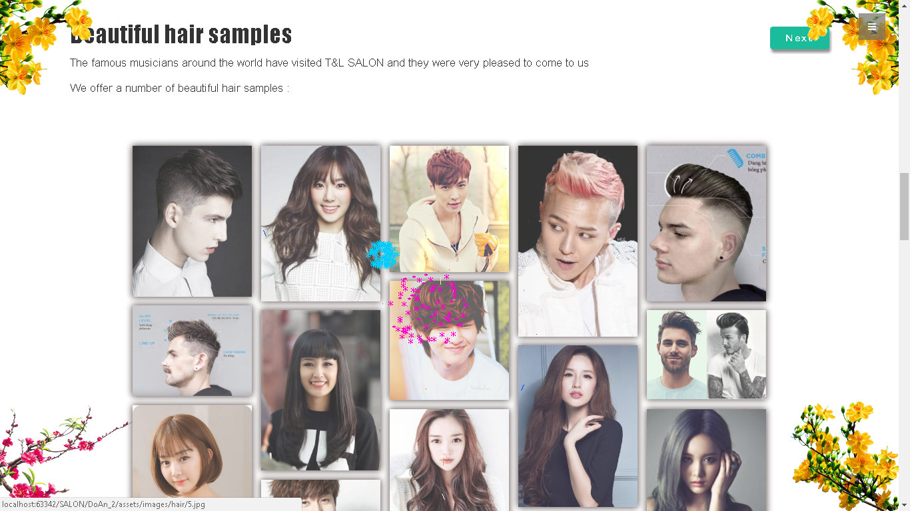

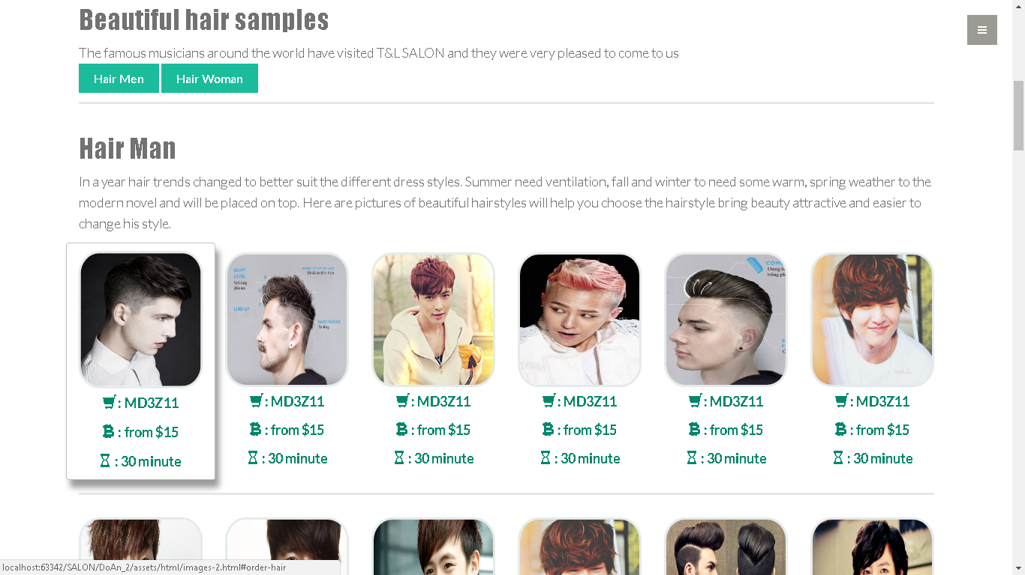

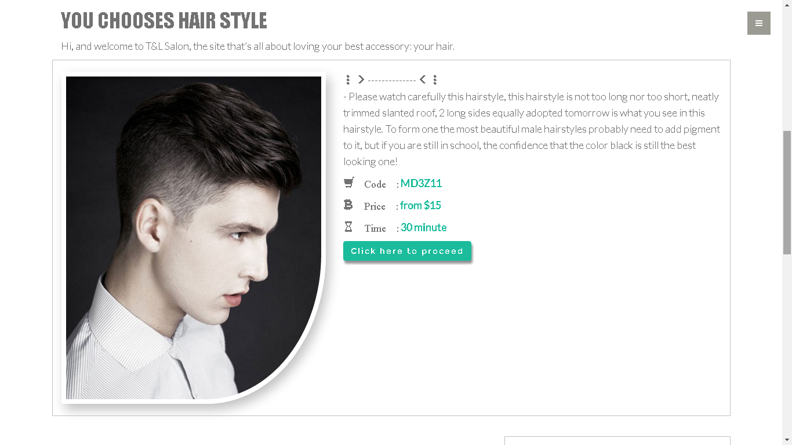

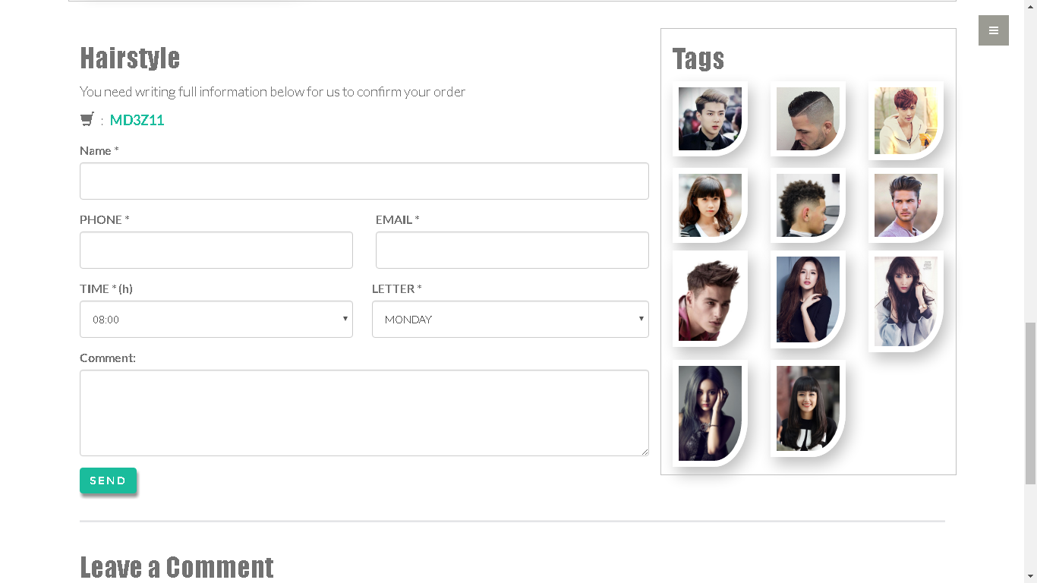

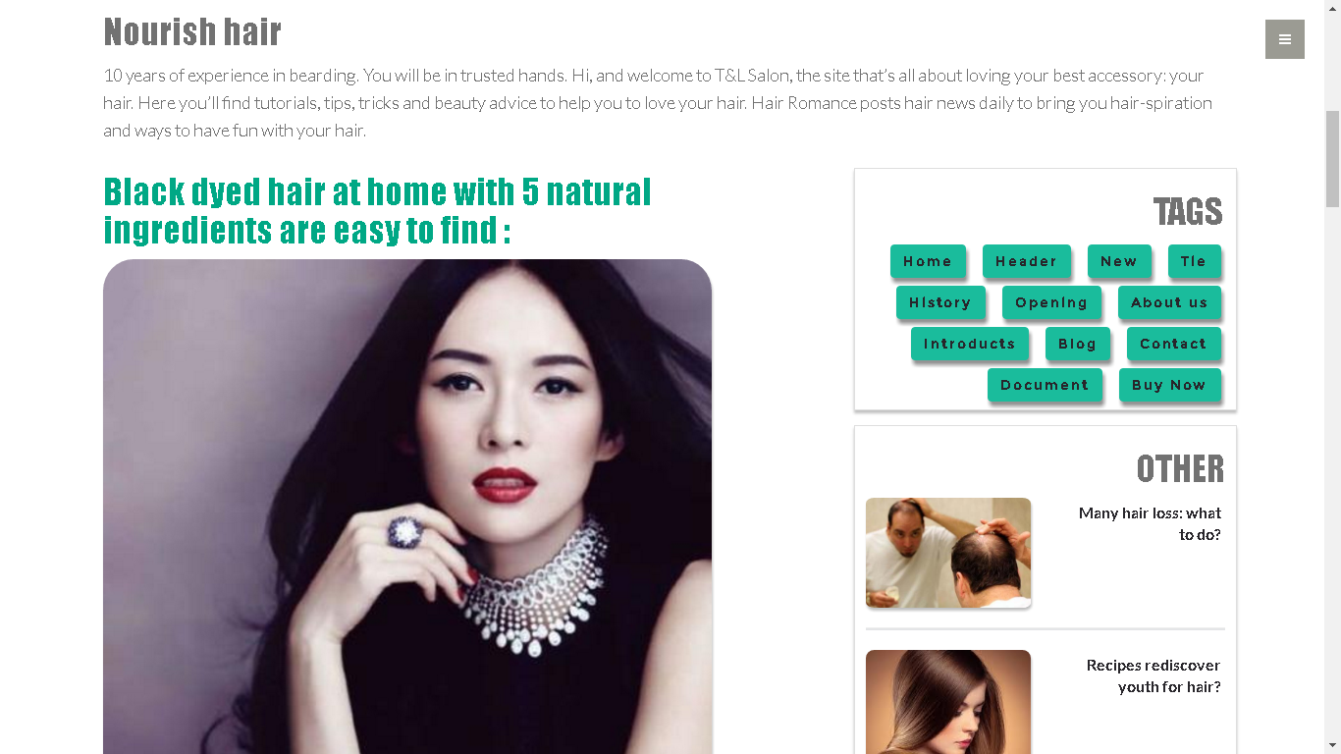

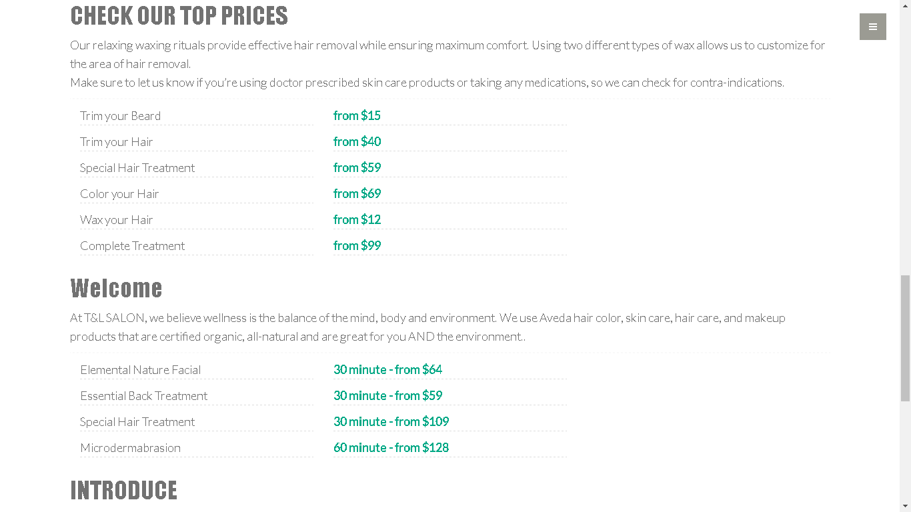

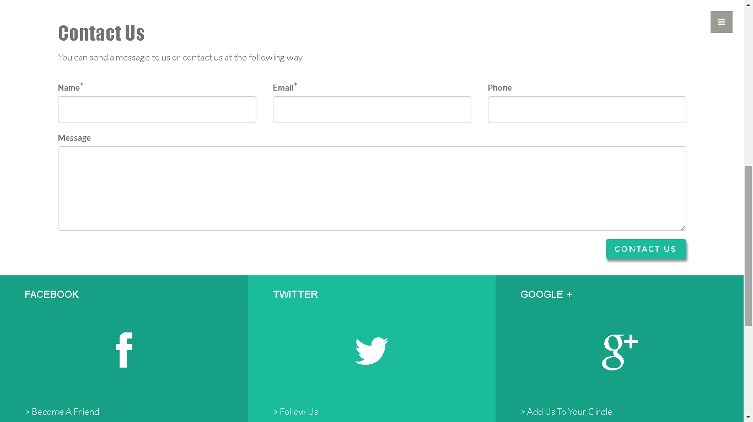

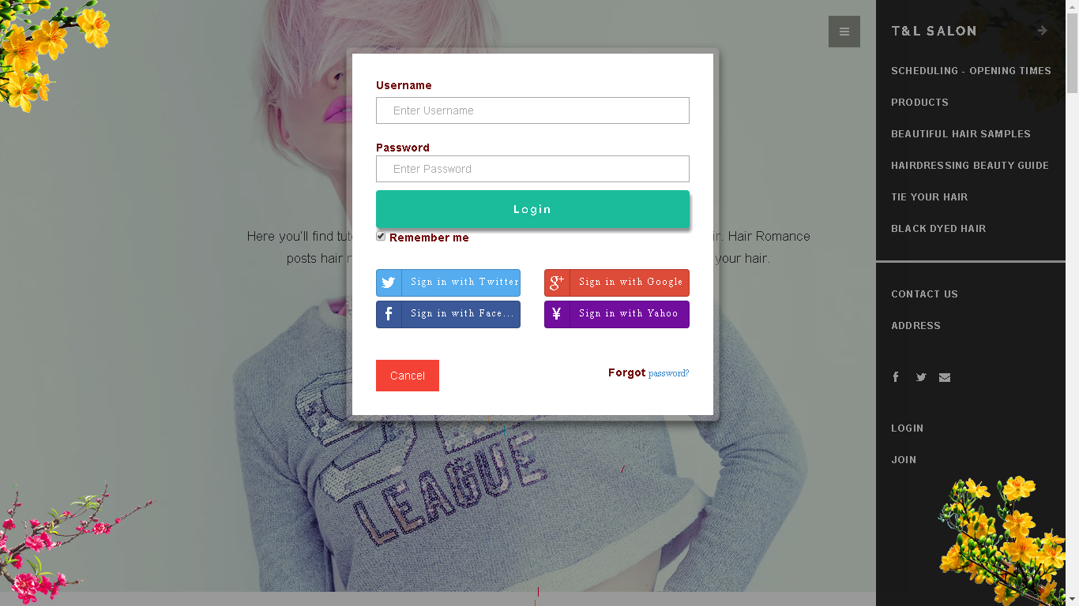

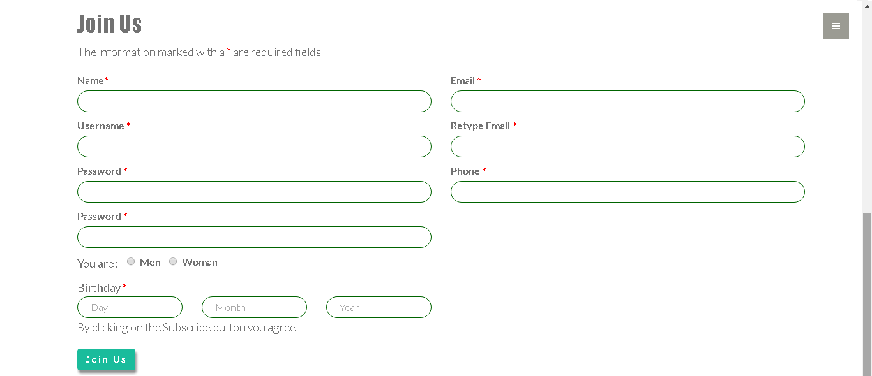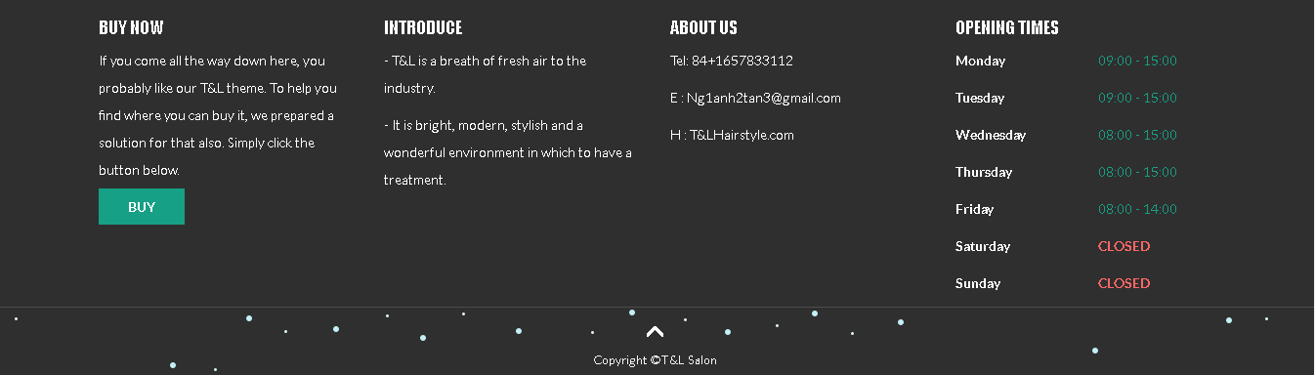

1. **T&L SHOP**

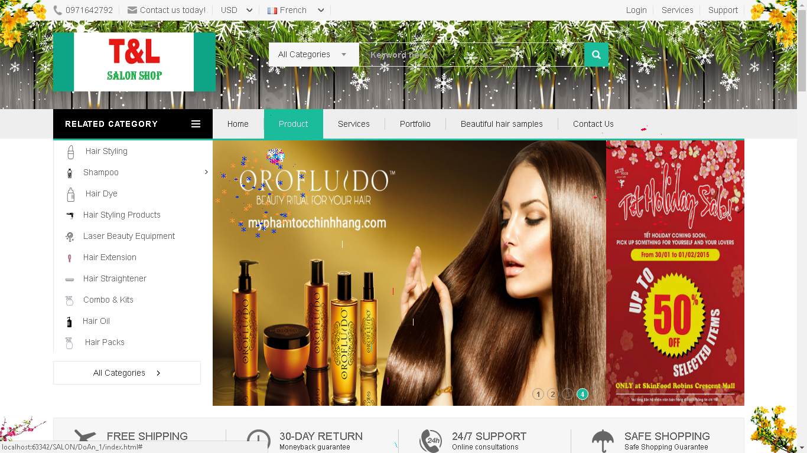

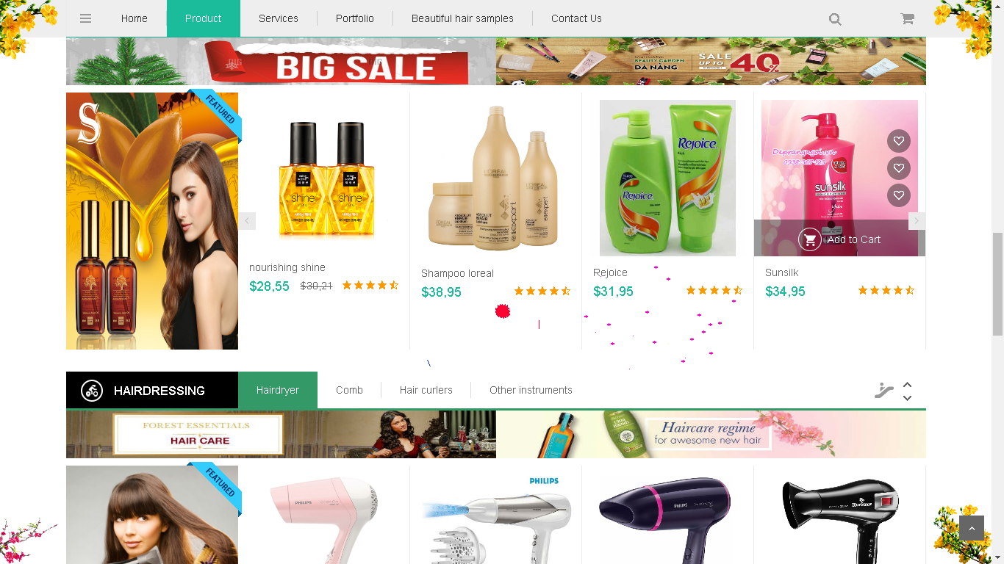

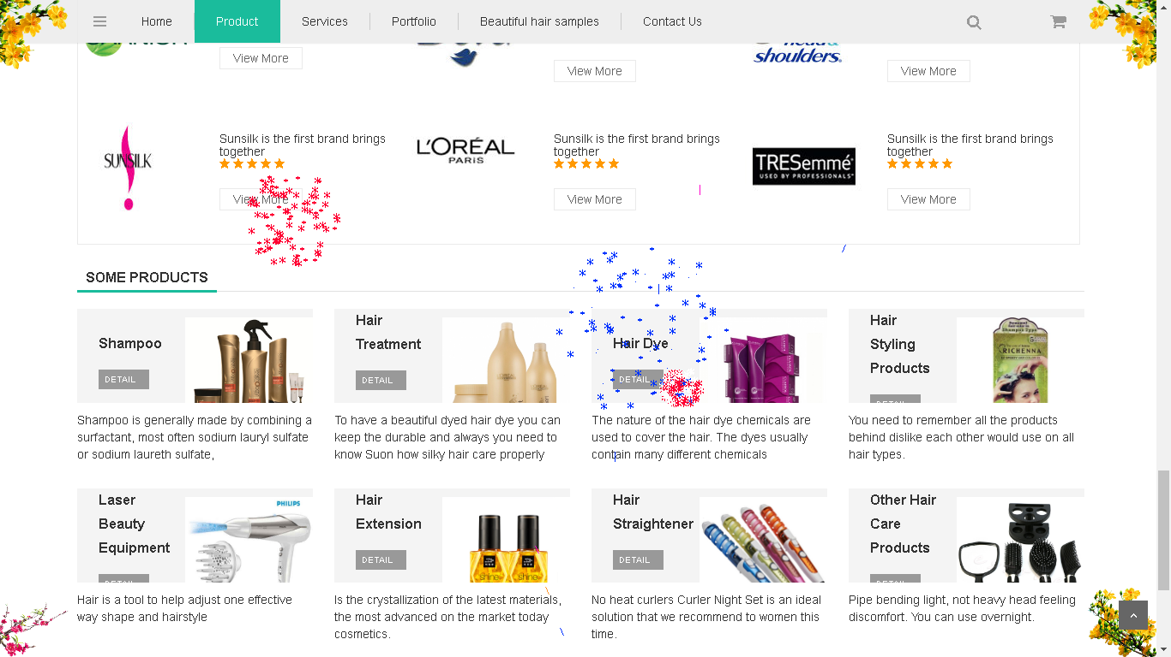

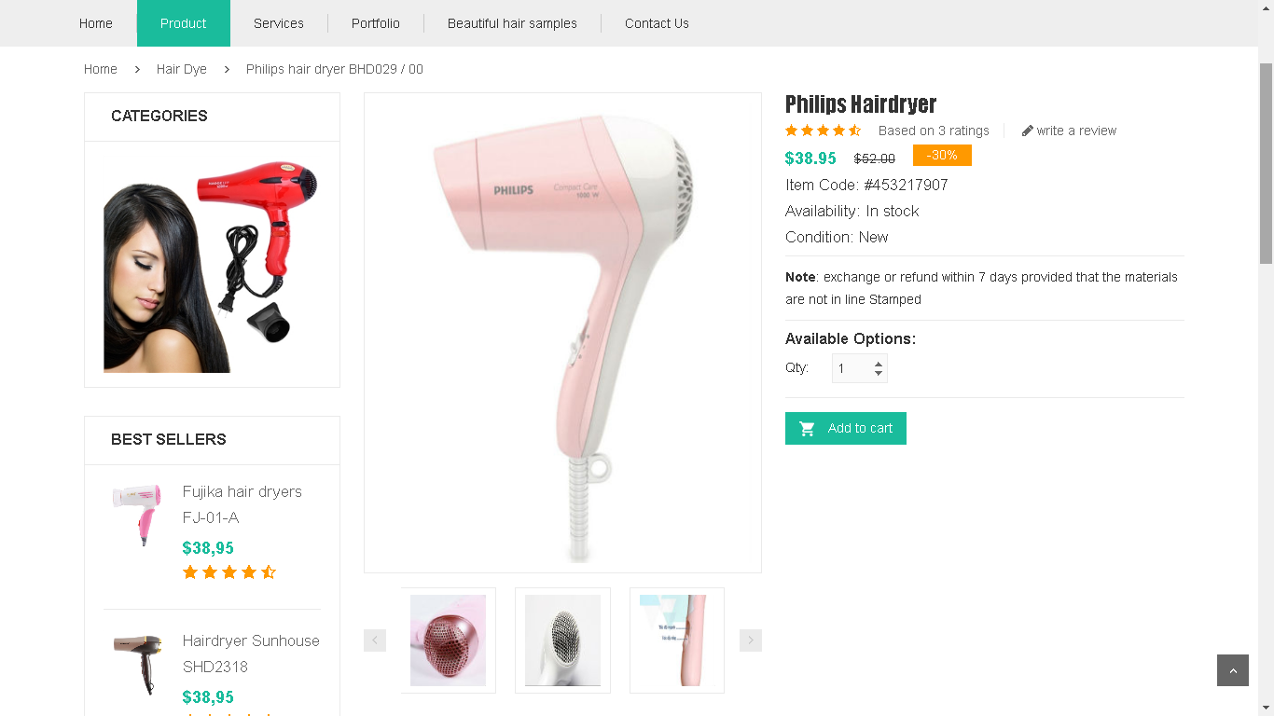

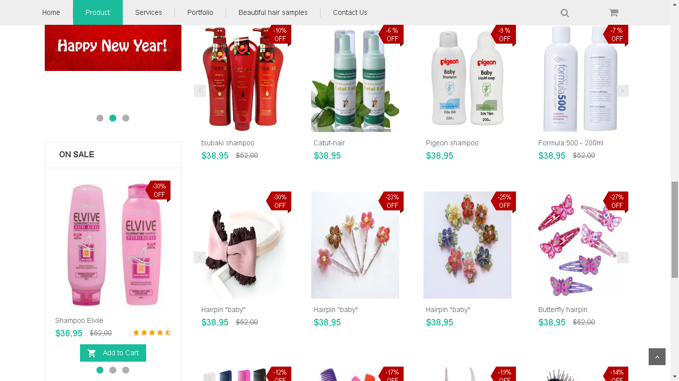

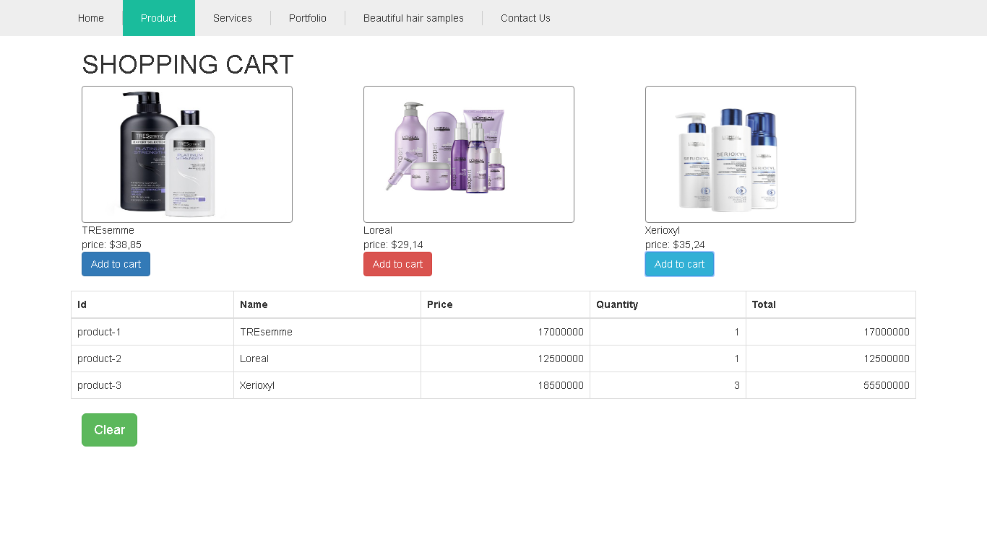

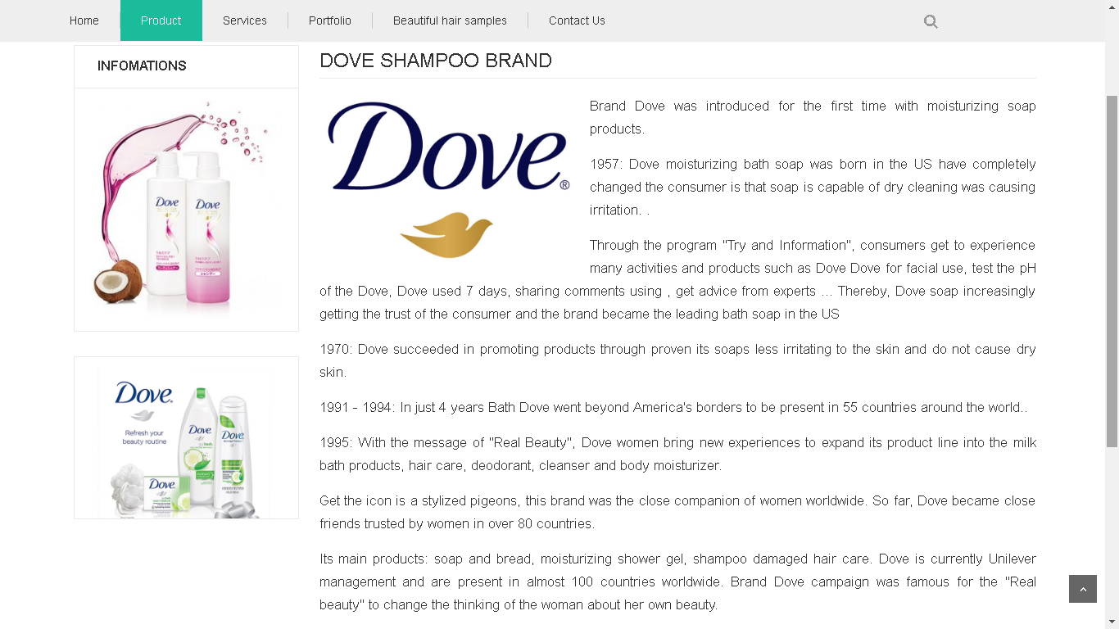

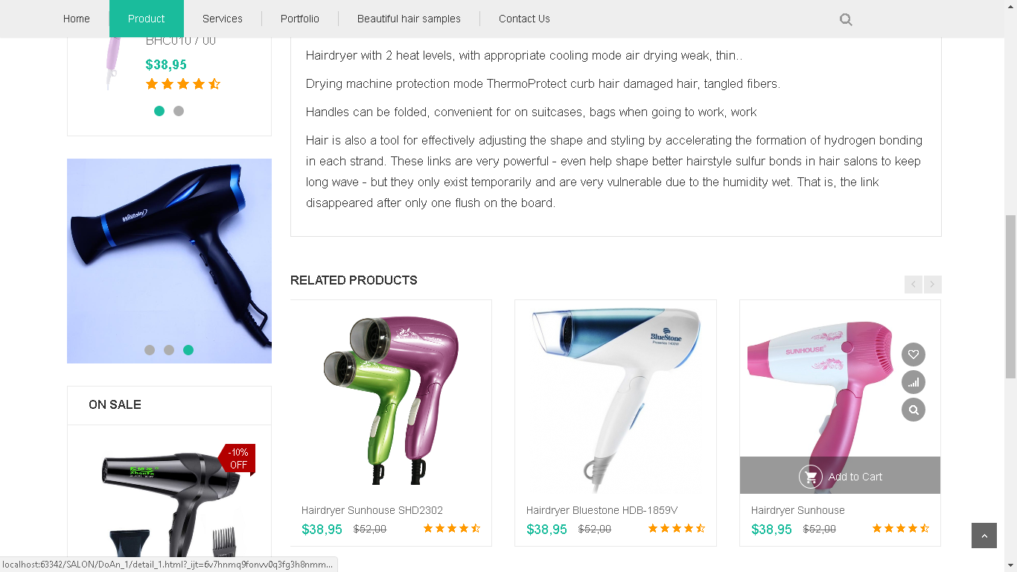

# IX. REFERENCES

1. **Bootstrap**
2. **Slider**
3. **jQuery Firework**
4. **Photos from the internet**
5. **Other**

# X. GUI OF WEBSITE

# XI. CHECKLISTS

1. **Check list of validation**

|  |  |
| --- | --- |
| **Option** | **Validate** |
| Can admin manage to the application? | **Yes** |
| Has the hardware and software been correctly chosen? | **No** |
| Are their function of the user to enter their comment? | **Yes** |
| Do all the option present in the application display the correct result? | **No** |
| Are there functions cart? | **Yes** |
| Are their functions for the user by products? | **Yes** |

1. **Submission Checklist**

|  |  |  |  |  |  |
| --- | --- | --- | --- | --- | --- |
| **No.** |  | **Yes** | **No** | **N/A** | **Comment** |
| **1.** | Is the users table to login the application after validation is performed on the username and password? | **Yes** |  |  |  |
| **2.** | Is there a form for user to enter personal information when buying or put item into the cart? | **Yes** |  |  |  |